Monster Mash

Objective:
- I will know that traits are passed from parent to offspring in a RANDOM process – an unplanned, but specific method.
- I will know that a genotype is made of two alleles (represented by letters) and that the capital letter always goes first.
- I will know that only one dominant (capital letter) allele is needed for a dominant trait to appear, but you need two recessive (lower-case letter) alleles for a recessive trait to appear.

What You Will Be Creating
You are making a family of monsters. You will make the mom, the dad, and the baby. Each monster has twelve characteristics. Each characteristic has two possible traits that can be selected by chance. You will make the mom and dad from scratch by flipping a coin to RANDOMLY select their genes, one allele at a time. Then, you will make the baby (the offspring) by using a Punnett Square. Finally, you will randomly select the possible genotype of the offspring.

Step by Step Directions:
(Check off as you go!)

1. | EXAMPLE:  HAIR  C = CURLY  c = STRAIGHT | Study the sample on the organizer. Notice the dominant allele for Curly hair is represented by the Capital Letter “C”. (Note: Each characteristic uses a different letter for its alleles.)
2. | 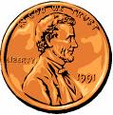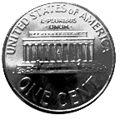  Dominant Recessive | When you flip the coin to select the genotypes of each trait remember…  Heads is Dominant and  Tails is recessive
3. | BODY SHAPE  B = TRIANGLE  b = SQUARE  COLOR = BLUE | Look at the 1st characteristic – Body Shape. Notice the possible genotypes & phenotypes for Body Shape.
Traits for the Mother & Father Monster
4. | 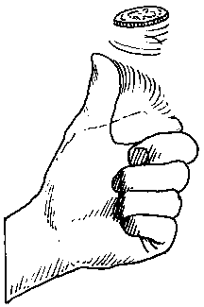 | Flip a coin to determine the first allele in the mother’s body shape genotype. Write down the letter of the allele for the trait in the genotype column. If it is a capital B, put it on the first space, if it is a lower-case b, put it on the second.
5. |  | Then flip the coin again. Write the letter of the second allele in the empty space remaining. You now have the mother’s full genotype.
6. | or | Now, write down the mother’s phenotype in the phenotype column.  **Remember, if there are any “B”s, the phenotype is the dominate trait.
7. REPEAT steps 4, 5 & 6 for the Father Monster.
(Now you know the body shape genotype and phenotype for the mom and the dad.)

Traits for the Baby Monster
8. | “Punnett Square” | To figure out which alleles the baby could inherit, you will fill in the Punnett Square using the allele combinations from mom and dad.
9. | Dad  B B  B  Mom  B | Write the Dad’s genotype letters across the top of the box. Write the Mom’s genotype letters down the left side of the box.
10. | Dad  B B  B BB BB  Mom  B Bb BB | Match up each father allele with a mother allele until all possible combinations are shown.  This is like the different possible combinations of alleles that join from the sperm and eggs.
11. | 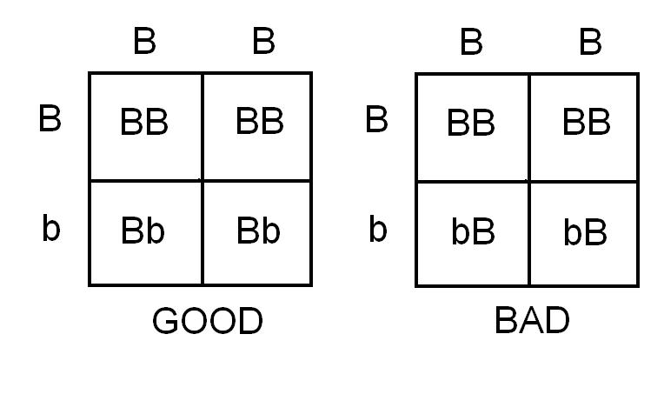 | Double check – are the capital letters all on the left?
12. | 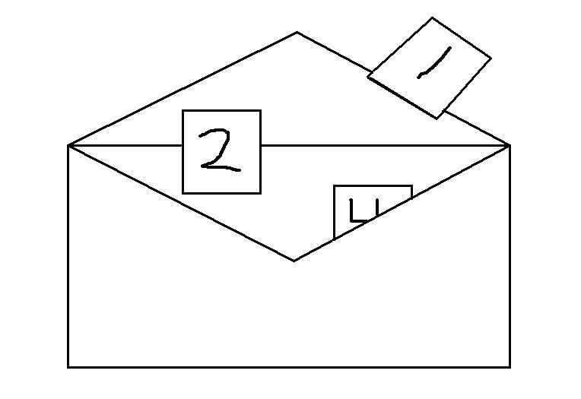 | Now, randomly (no peeking) pick a number 1, 2, 3 or 4 from the envelope.

13.  2  BB | 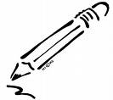 | The baby monster’s genotype is the one in the box of the Punnett square with that same number.
14. |  | Write the number you pulled out & the baby’s genotype in the BABY MONSTER genotype column.
15. | or | Lastly, write the baby monster’s phenotype in the phenotype column. **Again, if there are any Capital letters, the phenotype is the dominant trait.

Now, you have the hang of it.
16. | 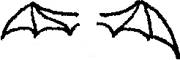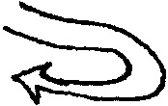  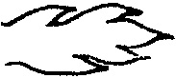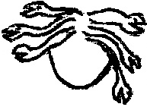 | REPEAT these steps (4 – 6 & 9 – 15) for each of the remaining eleven characteristics:  head shape, eyes, hair, tail, breath, ears, nose, mouth, skin, wings, and arms & legs.

17. Using paper provided by your teacher, DRAW & COLOR YOUR MONSTER FAMILY to match the phenotypes on the chart. (Use the colors listed in column 1 of the chart.)

18. KEEP ALL OF YOUR WORK! The Organizer Charts and your Drawings will be added to a folder with other work to be completed later. (Double Bubble Map & Gender of Baby Monster)

